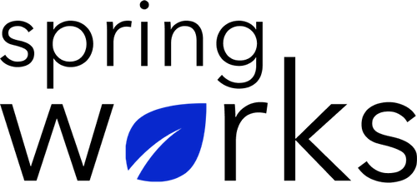
Free Template – Company Event Evaluation Survey

Ask employees how satisfied they were with the event

This company event evaluation survey template helps you assess how well any internal event was organized and how helpful it was from the perspective of your employees.

Communication (to be added as review instructions):

All answers you give will be treated with the utmost sensitivity, and the information will not be used for any other purpose apart from planning and improvement. Please answer this quick survey by <HOUR OF THE DAY> on <DATE>.

Demographic Information:

The following information is requested so that meaningful analysis and comparisons of group results can be made. Please check the circle corresponding to your answer.

Q: Your Department:

- Marketing
- Operations
- Tech
- Accounting
- HR

Q: Company Service:

- Under 1 Year
- 1-2 Year
- 3-5 Year
- 6-10 Year
- 10-15 Year
Company Event Evaluation Questionnaire

To answer clearly what you think or feel about each item, please follow these steps:

- Read each item fully before you start to mark your answer.
- Pick the one answer which most nearly says what you think or how you feel.
- While completing the questions, be sure to read the special instructions which are included.

Q: Overall, how entertaining was the event?

1 | 2 | 3 | 4 | 5 | 6 | 7 | 8 | 9 | 10

Q: After the event, how inspired did you feel?

1 | 2 | 3 | 4 | 5 | 6 | 7 | 8 | 9 | 10

Q: Would you recommend a similar event to a friend?

1 | 2 | 3 | 4 | 5 | 6 | 7 | 8 | 9 | 10

Q: What did you like about the event?

Q: What did you dislike about the event?

Q: How friendly was the staff?

- Extremely friendly
- Very friendly
- Not so friendly
- Not at all friendly
- Somewhat friendly

Q: The event was well organized and structured:

- Strongly agree
- Agree
- Neutral
- Disagree
- Strongly disagree

Q: Overall, were you satisfied with the venue, and were you able to see and hear the presentations clearly?

- Yes
- No

Q: Have you attended similar events before?

- Yes
- No

Q: Prior to the event, I got the needed information:

- Strongly agree
- Agree
- Neutral
- Disagree
- Strongly disagree

Q: Event length was:

- Much too long
- Too long
- Too short
- Much too short
- About right

Q: How likely are you to attend similar events in the future?

- Not at all
- Slightly
- Moderately
- Very
- Extremely

Q: What was the highlight of the event?

- Option 1
- Option 2
- Option 3
- Option 4
- Option 5

Q: How could we have improved your experience?

Q: Any other feedback or suggestions?

Thank you for sharing your opinions.

